**Perspectives on Asynchronous Tutoring: The Case of the Writing & Communication Center (WCC) eTutoring Service for Correctional Education**

**I. Ashland University C.E. Student Demographics**

Secondary Education (High School)

G.E.D. = 54%

H.S. DIPLOMA = 22%

Transfer students not declaring HS credential (post-secondary transfer credit)= ca. 25% (>30)

Sex  
MALE = 79%  FEMALE = 21%

% of our CE students who are people of color

| American/Alaskan Native | 2.2% |
| --- | --- |
| Asian | 0.95% |
| Black/African American | 28% |
| Hawiian/Pacific Islander | 0.57% |
| Asian/Pacific Islander | 0.06% |
| 2 or more races | 0.03% |
| White | 63% |
| Not reported | 5% |

**II. English eTutoring Spring 2022 (pilot)**

In partnership with the Composition Department, the WCC launched the English eTutoring service offered to Correctional Education students taking English classes. During the pilot phase (Spring of 2022), eTutors provided asynchronous feedback on a variety of student questions to ensure our C.E. students receive writing support comparable to that offered to on-campus students.

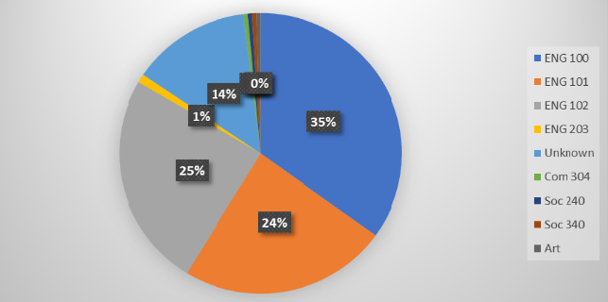

* During the spring semester of 2022, the English eTutoring service held 202 consultations, 35% of which were for ENG 100 while 24% and 25% for ENG 101 and ENG 102, respectively.
* ENG 203 accounted for merely 1% of these appointments; however, 14% of consultations were marked as unknown where students failed to identify with which course they were seeking help.

**II. English eTutoring Summer 2022**

The program transited from its pilot phase to an official stage during the Summer semester of 2022. The eTutors completed 64 consultations compared to 202 in the spring. As the chart below shows, most consultations were for ENG 100, the remedial English course.

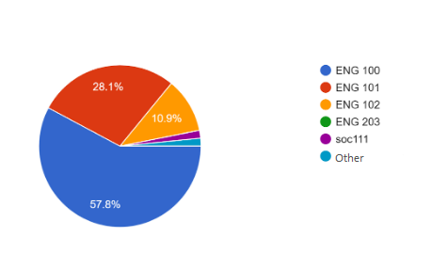

**III. English eTutoring Fall 2022**

During the Fall semester of 2022, the eTutors had a total of 124 consultations, the bulk of which (43%) were for ENG 101.

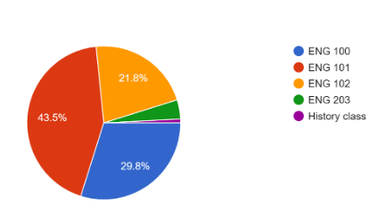

**IV. WCC eTutoring Spring 2023 (pilot)**

This past semester (Spring 2023), we expanded the service to include all C.E. courses in English, Communications, History, Religion, and Interdisciplinary Studies 490 sections. The expansion resulted in a record number of consultations (581), most of which were still for English classes.

